Software Engineering Notes

Dual Role of Software:

1. As a product
   1. It delivers the computing potential across networks of hardware
   2. It enables the Hardware to deliver the expected functionality
   3. It acts as a information transformer because it produces , manages, acquires, modifies, displays or transmits information
2. As a vehicle for delivering a product
   1. It provides system functionality(Tally)
   2. It controls other software(OS)
   3. It helps to build other software(Software Tool)

Objectives of Software Engineering

1. Maintainability
2. Efficiency
3. Correctness
4. Reusability
5. Testability
6. Reliability
7. Portability
8. Adaptability
9. Interoperability

Software = Program+documentation+licensing

Program – It is stage involved in the development of software

**Software Process Models**

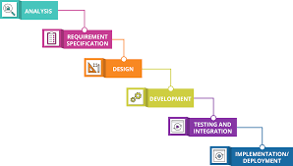

1. Analysis – To determine whether is would be financially and technically feasible to develop the software
2. Requirements Specification – to understand the exact requirement
3. Design – Transforming requirement specification into design models
4. Development – Actual coding and unit testing
5. Testing and Integration – Resultant system testing
6. Maintenance/Deployement – Resultant system at customer environment and changes in it

**Advantages**

1. The model is very simple and easy to understand
2. Each phase in this model is processed one at a time
3. It has very clear and well understood milestones
4. Reinforces good habits like define-before-design and design-before-develop
5. Model works well with smaller projects and projects where requirements are well/clearly understood

**Drawbacks**

1. No feedback mechanism
2. Difficult to accommodate change request
3. No overlapping of phases
4. Risk of failure

**Incremental Model**

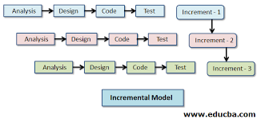

* Incremental development is done in steps from analysis , design, implementation , testing/verification, maintenance
* System development is broken down into many mini development projects
* Partial systems are successively built to produce a final total system
* Highest priority items is tackled first
* Once the requirement is developed , requirement for that increment is frozen

**Advantages**

1. The software will be generated quickly during the software life cycle
2. It is flexible and less expensive to change requirements and scope
3. Errors can be easily identified

**Disadvantages**

1. Problems might cause due to poor system architecture
2. Integration problems, if there is a problem in one unit which requires correction in all units , it will be very expensive
3. Not able to understand current project status

**Spiral Model**

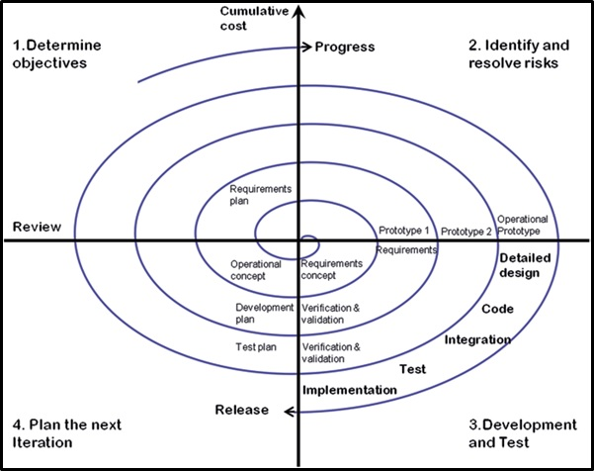

Each phase of spiral model in software engineering begins with a design goal and ends with client reviewing the process

The development process in spiral model starts with a small set of requirements and goes through each development phase for those of requirements

Phases in Spiral Model are

1. Planning or Objective setting
2. Risk Analysis
3. Engineering/Development and Test
4. Evaluation/Plan the next iteration

**Advantages**

1. Additional functionality or changes can be made at later stage
2. Cost estimation becomes easy
3. Continuous development help in risk management
4. Development is fast and features are added in a systematic way in spiral development
5. There is a space for customer feedback

**Disadvantages**

1. Not advisable for smaller project
2. Documentation is more as it has intermediate phases
3. Risk of not meeting the schedule or budget

Comparison between various SDLC Models

Rearewarewa

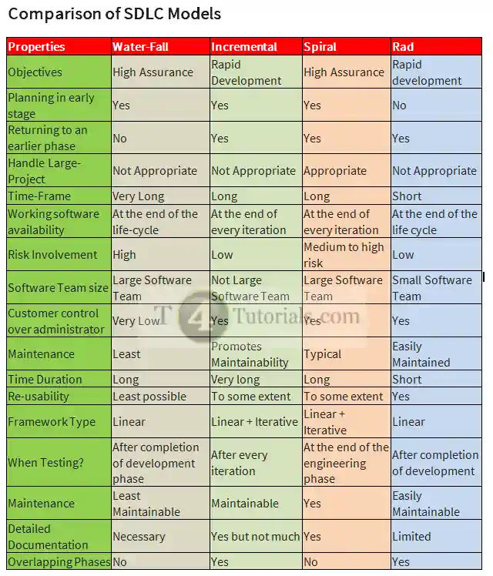

Requirements Engineering Process

